**Cellular life from the three domains and viruses are transcriptionally active in a hypersaline desert community**

**Gherman Uritskiy1, Michael J. Tisza1,2, Diego R Gelsinger1, Adam Munn1, *James Taylor1,3, and *Jocelyne DiRuggiero1**

1. Cell, Molecular, Developmental Biology, and Biophysics, Johns Hopkins University, Baltimore MD 21218
2. Lab of Cellular Oncology, NCI, NIH, Bethesda, MD 20892-4263
3. Department of Computer Science, Johns Hopkins University, Baltimore MD 21218

* Corresponding authors: [james@jamestaylor.org](mailto:james@jamestaylor.org) and [jdiruggiero@jhu.edu](mailto:jdiruggiero@jhu.edu)

* Correspondance :

Jocelyne DiRuggiero

jdiruggiero@jhu.edu

Johns Hopkins University

Department of Biology

3400 N. Charles Street, Mudd Hall 235

Baltimore MD 21218, USA

**Originality-Significance Statement**

While the metagenomic analysis of hypersaline environments has led to many discoveries, the transcriptional adaptations and functions of halophilic microbial communities in natural environments remain understudied. We performed the first robust meta-omic investigation of a hypersaline desert ecosystem, linking the genomic and transcriptional elements of the community. Our analysis unexpectedly revealed that Eukaryotes may be the main primary producers in this extreme environment, despite halophilic Archaea and Bacteria dominating the biomass. We also expand on the existing known diversity of halophilic viruses and demonstrate that they are transcriptionally active in their natural environments.

**Summary**

Microbial communities play essential roles in the biosphere and understanding the mechanisms underlying their functional adaptations to environmental conditions is critical for predicting their behavior. This aspect of microbiome function has not been well characterized in natural high-salt environments. To address this knowledge gap, and to build a general framework relating the genomic and transcriptomic components in a microbiome, we performed a meta-omic survey of extremophile communities inhabiting halite (salt) nodules in the Atacama Desert. We found that the major phyla of this halophilic community have very different levels of total transcriptional activity, at the selected time points, and that different metabolic pathways were activated in their transcriptomes. We report that a novel *Dolichomastix* alga – the only eukaryote found in this system – was by far the most active community member. It produced the vast majority of the community’s photosynthetic transcripts despite being outnumbered by members of the *Cyanobacteria*. The divergence in the transcriptional landscapes of these segregated communities, compared to the relatively stable metagenomic functional potential, suggests that microbiomes in each salt nodule undergo unique transcriptional adjustments to adapt to local conditions. We also report the characterization of several previously unknown halophilic viruses, many of which exhibit transcriptional activity indicative of host infection.

**INTRODUCTION**

The study of hypersaline systems has greatly advanced our understanding of core microbiology principles, evolution, and the origin of life itself (Oren, 2008; Paul and Mormile, 2017; Gunde-Cimerman et al., 2018). Halophiles and their activities have been extensively studied for their unique adaptations, phylogenetic diversity, and potential economic and scientific benefits. Halophilic microbiomes provide opportunities for exploring promising solutions for current and future global issues, particularly in the context of global warming (Paul and Mormile, 2017). The metagenomic components of several high-salt microbiomes have been partially resolved, particularly from salterns and hypersaline lakes, where assembly and binning of shotgun sequencing data has led to the discovery of hundreds of novel taxa (Hedlund et al., 2014; Andrade et al., 2015; Finstad et al., 2017; Ramos-Barbero et al., 2018; Uritskiy and DiRuggiero, 2019). However, the transcriptional and metabolic activities of such communities, which would provide insights into their real-time functioning, remain understudied (Ramos-Barbero et al., 2018).

While gene transcription does not necessarily indicate the functional activity of an encoded protein, pathways transcription can be a good proxy for indirectly detecting changes in activity levels, particularly when collecting proteomic data is difficult (Vogel and Marcotte, 2012). Characterizing the metatranscriptome of a natural microbial community puts into perspective the relationship between its transcriptional function and functional potential, and gives a more accurate view of the functioning of the community as a whole. Comparative multi-omics have shown that different taxonomic groups can constitute different fractions of metagenomic and metatranscriptomic components of the microbiome (Amato et al., 2019) and reveal the community members responsible for key metabolic functions in their respective ecosystems (Tripathy et al., 2016; Edwardson and Hollibaugh, 2017). However, metatranscriptomic studies are difficult to conduct in most extreme environmental microbiomes due to low available biomass and high sample complexity (Ramos-Barbero et al., 2018).

Extremophile endolithic (inside-rock) microbiomes of the Atacama Desert, Chile, are compelling ecological models for studying microbial community assembly because they are relatively simple and contained ecosystems (Wierzchos et al., 2018). Encased in rocks, these communities have a minimal exchange of biomass and nutrients with the outside, allowing each community to develop independently and, as such, providing insights into community structure replication ((Uritskiy et al., 2019; Finstad et al., 2017). Their sensitivity to perturbation also makes them suitable systems to investigate the effects of climate change on microbiomes (Uritskiy et al., 2019). In areas of the Atacama Desert with annual precipitation of less than 1mm, microorganisms have evolved the ability to survive inside evaporitic halite nodules (salt rocks) (Wierzchos et al., 2005). Microbial communities inhabiting the pores within these partially segregated salt nodules rely almost uniquely on atmospheric moisture absorbed via salt deliquescence (Robinson et al., 2015; Crits-Christoph et al., 2016). Saturated salt conditions, high UV and solar irradiance, and cycles of desiccation and re-hydration present unique challenges for these communities (Wierzchos et al., 2006; Wierzchos et al., 2018).

The major photosynthetic taxa of halite communities are a small number of *Cyanobacteria* species (*Chroococcidiopsis*, *Halothece*, and *Euhalothece)* and a single species of halophilic alga (*Dolichomastix*) (Finstad et al., 2017). These primary producers support several major groups of heterotrophs, including *Halobacteria* and *Bacteroidetes*, which constitute most of the system’s biomass (Robinson et al., 2015; Crits-Christoph et al., 2016). Halite communities also contain a diverse assembly of viruses, infecting members of both the Archaea and the Bacteria (Crits-Christoph et al., 2016). Halite communities have been shown to be metabolically active under *in-situ* conditions with measurements for respiration, with oxygen microelectrodes, and photosynthetic activity, using Pulse Amplitude Modulation (PAM) Fluorometry (Davila et al., 2015). Analysis of temporal (Uritskiy et al., 2019) and spatial (Finstad et al., 2017) dynamics revealed that water was the main driver for the taxonomic composition of these communities. It is also likely that the large relative humidity and temperature changes in the Atacama Desert, throughout the diurnal (day/night) cycle, have a significant impact on microbiome functioning. In that regard, a recent study showed that halite communities have the capability for transcriptional regulation via small non-coding RNAs (Gelsinger et al., 2019).

To address the paucity of knowledge on the transcriptional activities of halophilic microbial communities, we interrogated the metatranscriptome of a well-characterized halophilic community inhabiting salt nodules in the Atacama Desert. We sampled nodules from representative light and dark time points during the diel cycle, placing our transcriptional observations in the context of the metagenomic composition of the respective samples. We characterized the functional pathways transcriptionally active in the community and found a surprising degree of transcriptional activity of the community’s only Eukaryote. We also reported on the phylogenetic diversity and infective activity of viruses in the community.

**RESULTS**

**Variable transcriptional contributions of major taxa**

To investigate the transcriptional activities of the microbial community in halite nodules, the DNA and RNA components of several replicates were extracted and sequenced. Samples were harvested in Salar Grande, a salar in the Northern part of the Atacama Desert (Robinson et al., 2015) (Fig. S1), at 9 am and 9 pm, from six individual halite nodules per time-point (Fig. S1). Timepoints were selected based on field measurements (Fig. S2), and previous work (Davila et al., 2015), to maximize potential transcriptional differences within the community. Genomic DNA and total RNA for 12 biological replicates, each from a different halite nodule, were sequenced, yielding a total of 96.0M and 81.2M reads, respectively. RNA reads matching rRNAs were removed computationally, yielding 12.8M non-ribosomal RNA reads. Assembled contigs were taxonomically classified based on genes annotated within them. The DNA and RNA reads were then aligned back to these classified contigs and the overall taxonomic composition, at the metagenomic and metatranscriptomic level, was determined from the distribution of the reads aligning to each respective taxonomic classification. (Fig. 1). This analysis revealed differences between the community taxa abundance (fraction of DNA reads) and overall gene expression levels (fraction of RNA reads) with several taxa over- or under-represented at the transcriptional level compared to their relative abundance in the community. In particular, the total transcriptional activity of Eukarya, represented by a single metagenome-assembled genome (MAG; see following sections), was higher than their genomic abundance in the community; 8% of non-rRNA metatranscriptomic reads were mapped to eukaryotic contigs, compared to only 2% of metagenomic reads. In contrast, bacteria, particularly *Bacteroidetes,* represented a smaller fraction of the metatranscriptome compared to the metagenome (8% vs 15%).

To understand the relationship between the relative abundance of organisms and their transcriptional activity, we carried out an analysis at the level of individual contigs. The relative abundance of contigs, expressed in copies per million (CPM), was estimated from their DNA read coverage, and the contig transcriptional activity was estimated from the average expression of genes carried on the respective contigs, expressed in transcripts-per-million (TPM). We found that contigs from different taxa displayed different transcriptional activity levels, which were not necessarily correlated with their abundance levels (Fig. 2A). In particular, the three primary producers in the community – the *Halothece* and *Euhalothece* cyanobacteria and a *Chlorophyta* green alga – had similar average gene transcriptional levels despite being present at notably different genomic abundances. Contigs from the dominant cyanobacteria, *Halothece*, had high gene expression levels but, because of the high relative abundance of this organism in the community, the estimated transcriptional activity of the contigs relative to their abundance was low. In contrast, and as observed at the reads level, the algae contigs displayed extremely high levels of transcriptional activity but were present at very low genomic abundance (~2%). On the other extreme, *Nanohaloarchaea* had very low gene transcription levels and low relative abundance. The differences in abundance and transcriptional activity levels of other taxa were not as large, however significant variation in transcriptional activity was observed within the highly diverse groups of *Bacteroidetes* and *Halobacteria* (the dominant class within the *Euryarchaeota* phylum) (Fig. 2A).

Quantifying the relationship between relative abundance and transcription levels at the phylum level (Fig. 2B) or using metagenome-assembled genome (42 MAGs, completion>70%, contamination<5%; Data 1; Fig. 2C) supported our finding that the *Chlorophyta* (algae) produced an order of magnitude more transcripts (adjusted for genomic abundance) than most other MAGs in this community. In terms of the total number of transcripts (Fig. 2B, 2C), algae contributed more to the metatranscriptome than both of the other photosynthetic members combined. While alga’s organelle genomes were much more numerous relative to the chromosomal genome (approximately 10X for mitochondria and 20X for chloroplasts), we found that even when adjusting for genome copy numbers, the chloroplasts were nearly 10X more transcriptionally active than the *Cyanobacteria* (Fig. 2C). The alga was taxonomically identified to be in the class *Mamiellophyceae,* whose membershave been previously characterized to have a single mitochondrion and chloroplast (Robinson et al., 2015; van Baren et al., 2016). This suggests that the coverage differences between the halite alga’s main chromosomes, mitochondria, and chloroplasts were the result of multiple genome copies in each organelle.

While some taxa were more transcriptionally active than others, we also found that the transcriptional activity of MAGs (expressed as the ratio of total RNA expression to the total DNA abundance) changed significantly between replicates (Fig. S3). This variation in activity was so great that an attempt to correlate the abundance and transcriptional levels of any given MAG across replicates (Fig. S4A) was successful for only a small subset of organisms (Fig. S4B). We verified that these findings were not the results of binning biases by repeating the analysis at the contig level (Fig. S4C, D).

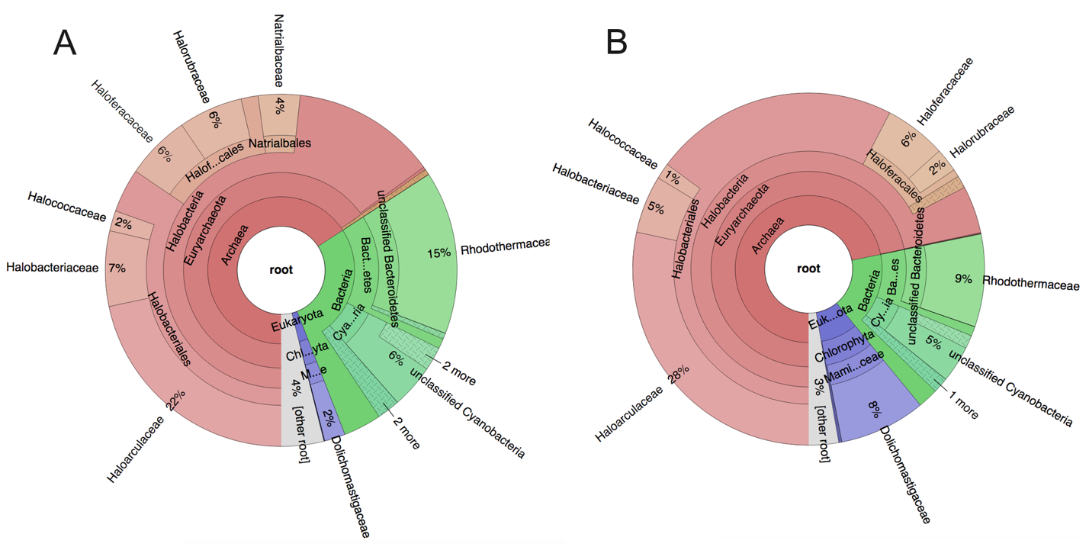

**Fig. 1**: Taxonomic composition of the halite community estimated from the metagenome (A) and metatranscriptome (B). Relative compositions were calculated from the read coverage of contigs annotated to each taxon. The contigs were first classified based on the phylogenetic lineages of the genes that they carried, estimated with the IMG annotation service.



**Fig. 2**: Transcriptional activity vs abundance of contigs and metagenome-assembled genomes (MAGs). (A) Total transcriptional activity (y-axis) of contigs shown in relation to their abundance in the metagenome (x-axis). Relative transcriptional activity (y-axis) of contigs (B) and MAGs (C) shown in relation to their average relative abundance (x-axis) and total contribution to the transcriptome (circle size). The total transcriptional activity of a given contig or MAG was estimated to be the median read expression (transcripts per million reads) of its genes. The total relative abundance was estimated from its average DNA read coverage (copies per million reads). Phyla are color-coded.

**Highly expressed functional pathways**

Investigating the expression levels of functional pathways from the KEGG Brite database in the halite community allowed us to identify highly transcribed functions. The transcriptional activity (transcripts per million reads, or TPM) of pathways was estimated from the sum of expression values of all the genes in a pathway and standardized to an equal sum of pathway TPMs in each replicate. Interestingly, the Euclidian distance hierarchical clustering between RNA replicates based on pathway expression did not reflect the sampling time-points nor the taxonomic compositions of the samples (Fig. 3). Most highly-expressed pathways, including translation, nucleotide metabolism, amino acid metabolism, and DNA replication and repair, were also present at high levels in the functional potential (copies per million of DNA reads, or CPM). In contrast, photosynthesis was the most highly expressed pathways in the community but had relatively low levels of abundance at the DNA level, which were similarly estimated from the total DNA read coverage of genes in each pathway (see methods). The opsin production pathway was also expressed at relatively high levels when taking into consideration its low abundance in the functional potential.

By standardizing the abundance and expression values of each pathway to the maximum value (abundance or expression), we were able to visually compare the relative expression of each pathway to its abundance in the metagenome and infer pathways transcriptionally prioritized by the community (Fig. S5). The Euclidian hierarchical clustering of community metabolic pathways resulted in three groups – those that were expressed lower, higher, or equal to their respective abundances in the community’s functional potential. Among the lowly-active pathways, we found cellular membrane and cell wall components, including most lipid metabolism and synthesis pathways, and glycan biosynthesis. Within the highly expressed pathway group, we found functions responsible for energy metabolism and carbon flow, such as photosynthesis and oxidative phosphorylation. The other group of highly expressed pathways dealt with protein synthesis turnover. In particular, multiple pathways for transcription and translation were very active, as were pathways for protein folding, trafficking, and degradation.



**Fig. 3**: Relative abundance and expression of major KEGG functional pathways in the metagenomic and metatranscriptomic samples. The pathway abundance (DNA) and expression (RNA) value were the combined total copies per million reads or transcripts per million reads (respectively) of the genes that constitute that pathway. All samples were standardized to equal total coverage of pathways.

**A highly variable functional profile**

To address the high inter-replicate variation between replicates in pathway RNA expression (Fig. S5) and investigate how pathway abundance contributes to this heterogeneity, we computed the variation of KEGG pathway abundance or expression values across replicates, standardized to range from 0 to 1. This transformation allowed for direct comparison of the variation in pathway abundance to the variation in pathway expression in the whole community or for a taxon of interest. Across all of the community pathways, we found a greater variation in pathway expression levels than pathway abundances (Fig. 4). This was true for all tested major taxa in the community (Fig. S6), suggesting that while the overall functional potential of the community remained relatively stable between replicates, consistent with previous findings, their transcriptional activity changed substantially in individual halite nodules.



**Fig. 4**: Heat maps showing the inter-replicate variation in (A) the metagenomic functional potential and (B) the metatranscriptome. KEGG pathways are shown along the x-axis and their metagenomic abundance (counts per million reads) and metatranscriptomic expression (transcripts per million reads) are shown for each replicate (y-axis). These abundance and expression values were additionally standardized to the highest value in each column to highlight variation differences (encoded in color map).

**No transcriptional differences detected between 9 am and 9 pm**

Samples for metatranscriptomic (and the corresponding metagenomic samples) were collected at two timepoints during the diurnal cycle, at 9 am and 9 pm with six replicates, each from a different halite nodule, to uncover temporal transcriptional adaptations of community members. The 9 am time point, ~3 hours after sunrise, was characterized by bright light (1500 $µmol photons.s^{-1}.m^{-2}$), relatively low air humidity (RH, 42%), and high temperature (27 °C). In contrast, the 9 pm time point, collected ~3 hours after sunset, was characterized by complete darkness (1.2 $µmol photons. s^{-1}{.m}^{-2}$, relatively high RH (60%), and low temperature (21 °C) (Fig. S2). Differential expression analysis was performed on the entire community, standardizing the gene expression to the abundance of its contig in the DNA or the total contig expression in the RNA (Fig. S7A). DESeq2 identified differentially expressed genes, however, the false discovery rate was greater than 5%, and the over- and under-expressed genes belonged to a seemingly random set of pathways. This analysis was also repeated for individual high-quality MAGs (>70% completion, <5% contamination), including the *Cyanobacteria* and *Dolichomastix* MAGs (Fig. S7 B,C). Doing so allowed for a more robust standardization scheme that accounted for the abundance (or total expression) of the entire organism, but did not yield any significant differentially expressed genes. We were also unable to detect significant differences in total pathway expression (Fig. 3).

**Pathway expression enrichment in major taxa**

We further explored the pathways most transcribed for each of the major taxonomic groups in the community, *Halobacteria, Bacteroidetes, Chlorophyta* (green algae), *Cyanobacteria*, *Proteobacteria, Actinobacteria, and Nanohaloarchaea,* by computing the ratio between the standardized pathway expression to pathway abundance (in the metatranscriptome and metagenome, respectively; Fig. S8). Importantly, these ratios did not represent a taxon’s overall functional landscape, but rather the degree to which a specific pathway was expressed.

While each major taxon in the community had a unique transcriptional profile, we found many similarities between their highly expressed pathways. For all major taxa, except *Nanohaloarchaea*, protein folding, sorting, and degradation pathways were the most highly expressed pathways. General carbon metabolism and oxidative phosphorylation were also highly expressed, although the specific sugar metabolism pathways varied. The community's least active members – the *Nanohaloarchaea* – were the most different from the other community phyla. Their only highly-expressed pathways were for nucleotide metabolism, transcription, and translation as well as pathways for metabolizing simple organic molecules such as fructose and pyruvate. Alignments with BLAST were used to identify fragments of the SPEARE gene encoding a protein essential in *Nanohaloarchaea* docking to their hosts (Hamm et al., 2019) in two of the MAGs (T17_Nanohaloarchaea_45_3 and T17_Nanohaloarchaea_46_6; Data S1), however, none of these genes were expressed in the metatranscriptome.

Not surprisingly, the two oxygenic photosynthetic groups in the community, *Chlorophyta* and *Cyanobacteria,* clustered together in their transcriptional activity. They were the only taxa to carry and express the photosynthesis pathway, which was highly active in both. However, expression profiles for other metabolic activities were quite distinct, with *Chlorophyta* strongly prioritizing glyoxylate metabolism and *Cyanobacteria* prioritized fructose and pentose metabolism. The opsin biosynthesis pathway, which produces the light-driven proton pumps in *Halobacteria* (bacteriorhodopsin) and *Bacteroidetes* (xanthorhodopsin), was one of the most highly expressed pathways in the metatranscriptome, compared to the metagenome, and was predominantly expressed in *Halobacteria*.

**Extraction of *Dolichomasti*x alga genome and characterization of carbon-fixation contributions**

The halite community harbors a unique alga that belongs to the *Dolichomastix* genus (Robinson et al., 2015). Through a combination of assembly and binning methods, we reconstructed the alga chromosome, chloroplast, and mitochondrion draft genomes. The metatranscriptome was also assembled to obtain the complete sequence of the 18S rRNA gene sequence. The latter sequence was found to be 99% identical to the sequence previously extracted from the halite microbiome using an amplicon-based approach (Robinson et al., 2015), and 94% identical to a putative *Dolichomastix* alga found in Lake Tyrell in Australia (Heidelberg et al., 2013). Re-evaluation of the phylogenetic placement of this sequence confirmed that the halite alga belongs to the *Dolichomastix* genus (Fig. S9).

Evaluating the relative contributions of oxygenic photosynthetic members to the functioning of the community revealed that the halite alga contributed significantly to photosynthesis. We identified several key genes from the photosynthetic pathway, a set of which were found in all three organisms capable of photosynthesis, the alga *Dolichomastix* and the two *Cyanobacteria* (Fig. 5). For almost every photosynthetic gene, particularly photosystem I (*psa)* and most photosystem II (*psb)* genes, the algae contributed an order of magnitude more transcripts than both of the *Cyanobacteria* combined. We also identified components of the carbon fixation pathway in all three phototrophs and found that the chloroplast gene encoding for RuBisCO was the second-highest expressed non-ribosomal gene in the entire alga (after *psb*D).

Given the high importance of the *Dolichomastix* alga for community carbon fixation, we further characterized its genome with respect to its closest fully sequenced phylogenetic relatives *Ostreococcus tauri* and *Micromonas pusilla* (marine algae), and another halophilic alga *Dunaliella salina*. The extracted *Dolichomastix* chromosomal genome was 10.3 Mbp long, compared to 13.1 Mbp in *O. tauri*, 22.4 Mbp in *M. pusilla*, and 343.7 Mbp in *D. salina*. Using BUSCO (Seppey et al., 2019), the *Dolichomastix* genome was evaluated to be 45.3% complete with 0.2% contamination, however, given the lack of highly compact eukaryotic genomes in the BUSCO database, the completion value might be underestimated. The chloroplast and mitochondrion genomes of the halite alga were 95 Kbp and 46 Kbp, respectively, similar to those in *O. tauri*, 72 Kbp and 44 Kbp, respectively (*O. tauri* is the only member of *Mamiellophyceae* with known organelle sequences at the time of this publication) (Robbens et al., 2007). All four algal genomes were functionally annotated with the same method and the isoelectric point (p*I*) for each predicted protein was estimated (Fig. S10A). We found that the pI distribution for the predicted proteome of the *Dolichomastix* alga was significantly different from that of *D. salina*, but relatively similar to its non-halophilic closest phylogenetic relatives *M. pusilla* and *O. tauri*. However, the non-halophile genomes displayed a trimodal pI distribution curve, with a notable fraction of the genes predicted to encode for proteins with a pI of 11.0 or greater. *Dolichomastix,* on the other hand, lacked this third peak, similarly to the more distant but halophilic alga *D. salina*. Of the few *Dolichomastix* proteins with a high predicted p*I* (p*I*>11) were histone and DNA-associated proteins, which need to be alkaline to function.

To investigate whether the genes encoding for high pI proteins in *M. pusilla* and *O. tauri* were present in the halite *Dolichomastix,* we aligned the amino acid sequences of the *M. pusilla* and *Dolichomastix* genomes. Of the 105 *M. pusilla* genes encoding for high-p*I* proteins that were found to have homologs in *Dolichomastix*, 80 encoded for proteins with a significantly lower p*I* in *Dolichomastix* (Fig. S10B). These proteins were not significantly enriched for any specific pathway or cellular compartment, but many were chaperones, mRNA processing proteins, and DNA-binding proteins.

To further compare the halotolerant *D. salina* and *Dolichomastix* genomes, we investigated homologs of important high-salt adaptation proteins. Previous proteomic studies of

*D. salina* identified 51 cellular and 46 membrane-bound proteins that were upregulated under high-salt stress (Liska et al., 2004; Katz et al., 2007). We mapped these genes to the *Dolichomastix* genome and found 33 homologous genes with a potential role in high-salt tolerance. Of these, all were expressed in *Dolichomastix* and a significant majority were highly expressed (>10TPM, Fig. S10C). Using this homologous set of genes with potential roles in high-salt tolerance in *D. salina*, we identified several highly expressed chaperones and heat-shock proteins in the *Dolichomastix* transcriptome, as well as several mitochondrial and chloroplast genes (Data S3). The predicted proteome in the chloroplast and mitochondria generally favored high-*pI* proteins compared to the main cellular compartment, although the small number of organelle genes may bias the observed *pI* distributions, particularly in the mitochondria (Fig. S10D).



**Fig. 5**: Expression (transcripts per million) of photosynthetic and carbon fixation genes identified in all the genomes of the three organisms capable of oxygenic photosynthesis in the halite community.

**Viruses are transcriptional active in the halite community**

We investigated viral diversity and transcriptional differences in the halite community using the sequences of homologous viral proteins, across samples. We extracted and functionally annotated 91 viral contigs from the metagenome, ranging in size from 5 Kbp to 51 Kbp. The halite viruses included members of the order *Caudovirales* (prokaryotic head-tail viruses including families *Myoviridae*, *Siphoviridae*, *Podoviridae,* and so-called *Haloviruses*) and of the archaeal virus families *Pleolipoviridae* and *Sphaerolipoviridae* (Fig. S11). The extracted viral contigs represented expansions of some extant genera (as determined by VContact2) while several contigs established previously unidentified genus-level clades. CRISPR spacer and nucleotide sequence similarity between viral genomes and host chromosomal regions were used to identify putative hosts of prokaryotic viruses. This approach led to the identification of the hosts for 44 viruses and revealed that the viruses primarily targeted *Halobacteria* and *Salinibacter* hosts for infection. The most abundant and transcriptionally active viruses belonged to a new clade of *Myoviridae* viruses, predicted to infect members of the *Halobacteria* class (Fig. 6). Interestingly, most highly transcribing viruses were active in only a few samples. The most highly expressed genes were annotated as being virion structural components or DNA replication/mobilization.

For a virus to be transcriptionally active, it needs intracellular access to a host cell, suggesting that the activity level of a given virus in a sample is dependent its abundance and that of its host, but also in its infection success and transcription rates. Consistent with this, we found that a virus’s high genomic abundance did not necessarily lead to high transcriptional activity. In a given sample, many transcriptionally active viral contigs were not highly abundant at the DNA-level, and highly-abundant contigs were not necessarily active at the transcriptional level (Fig. S12). Only 12 out of the 91 virus contigs showed a significant positive correlation (Pearson index *pval*<0.01) between viral abundance and viral transcriptional activity (Fig. S13), meaning viral abundance was not a good predictor for transcriptional activity and infection rates. Furthermore, we were unable to detect any statistically significant correlation between viral abundance or transcription and that of their respective putative host (as determined through CRISPR spacer alignment). We also found that most viruses had no detectable transcription in most samples (Fig. S12).

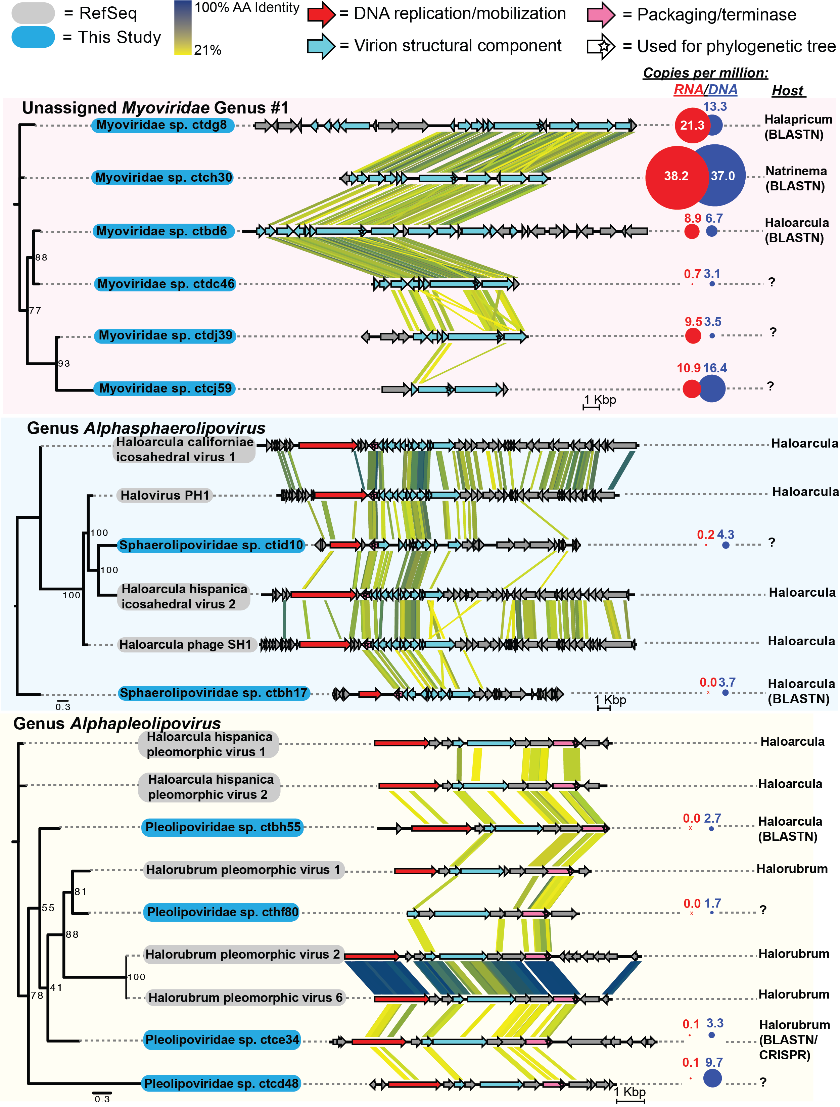

**Fig. 6**: Diversity of viruses in the halite community. Viral contigs from this study (in blue) annotated to a novel *Myoviridae* genus cluster and *Alphaspaerolipovirus* and *Alphapleolipovirus* genera, and viral contig from the RefSeq database (in grey). Genome maps were drawn and compared with TBLASTX and EasyFig. Circles represent metagenomic abundance (blue; copies per million reads) and total transcriptional activity (red; transcripts per million reads); putative hosts are shown on the right.

**DISCUSSION:**

Our analysis of both the metatranscriptomic and metagenomic components of a halite microbial community provided new insights into the functioning of this unique hyper-saline and endolithic ecosystem. Comparing the taxonomic composition of the metagenomic and metatranscriptomic elements of the halite microbiome, for the two time-points we selected, revealed that many organisms have a drastically different contribution to the community’s functions than what could be inferred from the previously reported metagenomic composition (Finstad et al., 2017). Similar trends were reported in environmental (Mobberley et al., 2015; Fortunato et al., 2018) and human-associated microbiomes (Franzosa et al., 2014) with characterized metatranscriptomes. Here, we found that the primary producers, the *Halothece* and *Euhalothece* cyanobacteria and a unique *Dolichomastix* alga, were the most transcriptionally active members of the halite microbiome. In contrast, *Nanohaloarchaea* were some of the least transcriptionally active members, with minimal and sometimes undetected levels of transcription. Recent characterization of *Nanohaloarchaea antarcticus* from Antarctica suggests that they are ectoparasitic, using a SPEARE protein complex to connect with their host, the halophilic archaeon *Halorubrum* lacusprofundi (Hamm et al., 2019). The low overall transcriptional levels of the halite *Nanohaloarchaea,* as well as undetectable expression of the SPEARE proteins, are indicative of their inactive state, most likely because they were not associated with a host at the time of sampling.

However, we were unable to detect significant changes in the metatranscriptome of the halite community between the 9 am and 9 pm collection time-points. These two time-points were chosen because they were likely to exhibit differences in transcriptional adaptations, particularly in the community’s phototrophs. Indeed, studies of microbial mats have shown major transcriptional differences in *Cyanobacteria* throughout the diel cycle, emphasizing the late-morning and sunset, as these time points typically exhibited the greatest differences, particularly in the expression of the photosynthetic machinery (Liu et al., 2011; Louyakis et al., 2018). Distinct temporal regulation of the photosynthesis and carbon fixation pathways, in response to light, has also been shown in aquatic *Cyanobacteria*, with light-harvesting photosynthetic genes being upregulated early in the light period, and the core oxidative pentose pathway being activated during the dark period (Saha et al., 2016; Welkie et al., 2019). Our 9 am time-point allowed two hours of adaptation to light, sufficient humidity to maintain functional activity, while avoiding a period of photo-oxidation, documented to occur around midday and early afternoon, as a result of the high solar irradiance in the Atacama Desert (Davila et al., 2015). Similarly, the 9 pm time point, 2 hours after sunset, allowed the microbiota two hours to adjust their transcriptional profiles to the dark conditions. While our inability to detect significant transcriptional differences between these two time-points might stem from erroneous predictions, we propose here an alternative explanation.

Previous research on the halite microbiome revealed variation in inter-nodule taxonomic composition and functional potential (Uritskiy et al., 2019), however, here we found even greater inter-nodule variation in at the transcriptional level. We suggest that this variation stems from a combination of varying rock topology, humidity and temperature metrics, which we could not measure at the time of sampling due to practical limitations. Water availability is essential for microbial communities in hyper-arid environments (Finstad et al., 2017; Meslier et al., 2018), and it is likely that internal relative humidity, over the diurnal cycle, varies greatly nodule to nodule, depending on their topology, exposure to sun and wind, and their unique capacity for water retention. Halite endoliths obtain most of their liquid water via salt deliquescence and, as the diurnal cycle progresses, nodules go through desiccation and rehydration cycles (Davila et al., 2008). During the night and early morning, at air RH above 75%, brine is formed inside the nodule, filling the pore space between halite crystals. During the day, water evaporates from increasing temperatures and dry winds, slowly drying the nodule. While the water dynamics inside each nodule is unique to that nodule, the overall conditions, and therefore the selective pressure from the environment, are very similar across all nodules, explaining the relative convergence of functional potentials of the halite communities’ pan-genomes. However, time-points, which are snapshots of each community inside each nodule in time, might capture very different environmental conditions for each community, resulting in highly variable metatranscriptomes across replicate nodules. Additionally, inter-cellular interactions, viral infection, and other stochastic biotic factors also likely influence the transcriptional landscapes found in each halite nodule at any given point in time, compounding the complexity of linking metatranscriptomic adaptations to specific factors. We, therefore, argue here that the lack of differences at the transcriptional level between our time-points might be the result of environmental conditions heterogeneity within nodule, rather than inadequate time-points. Regardless, our meta-omic analysis of the halite microbial community provides unique insights into the functioning of this community.

For example, we found that the novel halophilic *Dolichomastix* alga was responsible for producing nearly 9% of the community’s non-ribosomal transcripts despite representing only 2% of the community’s metagenome and it produced nearly 10 times more transcripts per genome copy than all the oxygenic photosynthetic prokaryotes. Previous studies have identified eukaryotic components in hypersaline environments with amplicon DNA and RNA sequencing (Heidelberg et al., 2013; Robinson et al., 2015; Harding and Simpson, 2018), however, this is the first study to investigate their transcriptional and metabolic contributions to community functioning with shotgun metatranscriptomics. The larger cell size of green algae compared to bacteria and archaea, and a higher basal metabolism required to survive in a high-salt environment, likely explain this novel finding. Broad estimates of the number of mRNA transcripts per average cell suggest 103-104 mRNA per bacterial cell and 105-106 mRNA for a 3000 μm3 eukaryotic cell (Ron Milo, 2016). Using previous microscopy-based observations of the halite alga, its volume can be roughly estimated to be roughly 1000 μm3, assuming a spherical cell shape (Robinson et al., 2015). Taken together, these estimates suggest that a halite alga cell is expected to produce 10-100 times more transcripts than the prokaryotic species, which is similar to what is observed in this study. This suggests that the transcriptional overrepresentation of the alga in this community likely stems from the cell size and functional differences between the eukaryotes and prokaryotes rather than activity levels. A similar disparity was found in a cow rumen microbiome, where a multi-omic study revealed that a small eukaryotic minority in the microbiome produced a significantly greater fraction of transcripts than expected from genome copy numbers (Comtet-Marre et al., 2017). We also found that the alga was responsible for producing the vast majority of the photosynthetic transcripts in the system, which could suggest that they are the major primary producers of the community. In a previous study of coastal sediments exposed to light, eukaryotic diatoms were shown to dominate the community metatranscriptome, particularly with extremely high numbers of photosynthetic pathway transcripts (Broman et al., 2017). While size explains the high contribution of eukaryotes to the metatranscriptome, it does not lessen their contribution to the microbiome functioning. The high amounts of biologically-available carbon released into the environment upon the death of such large cells would impact the community’s heterotrophs significantly more than that from the death of a much smaller cyanobacteria cell.

Most other community members (particularly *Halobacteria* and *Bacteroidetes*) of the halite microbiome are salt-in strategists, meaning that these halophiles selectively import potassium to counteract the osmotic pressure from high external sodium concentrations (Oren, 2008). Eukaryotes, which have not been observed deploying this energetically-favorable strategy, instead produce high internal concentrations of secondary metabolites to maintain osmoregulation. Previous studies with a halophilic alga *D. salina* reported the upregulation under high salt of major metabolic pathways involved in photosynthesis and carbon fixation to produce enough energy and glycerol-based secondary metabolites to actively balance high external salt concentrations (Chen and Jiang, 2009). Consistent with these adaptations, study, we found that the halite *Dolichomastix* alga had extremely high rates of photosynthesis and oxidative phosphorylation, likely producing similar secondary metabolites to counter-act external osmotic pressure (Oren, 2014; Polle et al., 2017). However, we were unable to detect evidence for active glycerol production in the alga’s transcriptome, as it was in *D. Salina* (Chen and Jiang, 2009). The predicted proteome for *Dolichomastix* exhibited a lack of high-p*I* proteins present in its non-halophilic phylogenetic relatives, reflecting. While p*I* distribution in eukaryotes is not indicative of function, it has been linked to cytoplasmic and nuclear pH (Elevi Bardavid and Oren, 2012), suggesting that the *Dolichomastix* alga might have a slightly different intracellular environment compared to non-halophilic members of its class, possibly due to adaptations for surviving in a saturated salt environment.

Our characterization of the halite microbiome’s viruses significantly expanded its existing sequence pool of viral diversity, providing a basis for more homology-based discovery for viruses in other halophilic environments. Expanding on our previous metagenomic work (Crits-Christoph et al., 2016), we were able to reconstruct three times more viruses. Many of these viruses belonged to novel putative genera, including a wide variety of viruses targeting *Halobacteria* and *Salinibacter* hosts. We also detected significant transcriptional activity of genes encoding for viral structural and replicative components in many of the discovered viruses, indicating that they may be actively infecting their bacterial and archaeal hosts. Many viruses, including a *Halobacteria* virus from the *Myoviridae* class, displayed very high gene expression values, suggesting that they may play a significant role in shaping the structure and composition of halite communities. Our analysis of these viruses also revealed that their transcriptional activity (and potentially active infection) did not correlate with their relative abundance nor with that of their host, indicating that their virulent success was dependent on a combination of deterministic (host and virus abundance) and stochastic factors (infectivity rates, host resistance accumulation) in any given halite nodule. These results are consistent with those of an ocean meta-virome study reporting that abundances of individual bacteriophages varied significantly across time and space in response to complex deterministic and random processes that influenced infectivity success (Luo et al., 2017). Such dynamic processes could result in the viral infectivity and activity variation observed in our study, with stochastic factors resulting in unique outcomes in each nodule.

Our study also sheds light on the transcriptional functioning of the halite community as a whole. The majority of highly-transcribed pathways in the halite metatranscriptome was related to cell maintenance and basal metabolic activities – transcription, translation, and processes associated with their regulation. The transcriptional landscape indicated rapid carbon turnover by the *Dolichomatix* alga, with its photosynthesis and oxidative phosphorylation pathways being some of the most consistently highly expressed in the community; indicative of high metabolic rates for production of secondary metabolites to counteract the high extra-cellular salt concentrations. The carbon fixed by *Cyanobacteria* and the alga by way of oxygenic photosynthesis is most likely the only source of primary production (Robinson et al., 2015) in the halite nodules. ATP can also be produced via rhodopsin light-activated proton pumps by heterotrophic *Halobacteria* and *Bacteroidetes* (Engelhard et al., 2018). We found that opsin production was one of the most upregulated pathways in *Halobacteria*, suggesting that supplementation of their ATP budget by light-driven reactions is essential for these organisms. This is consistent with the upregulation of energy-harvesting rhodopsins in *Halobacteria* during stress (Spudich, 1998) and other studies reporting that opsin-based proton pumps are important supplementary sources of energy for *Halobacteria* in energetically-taxing hypersaline environments (Grote and O'Malley, 2011; Ernst et al., 2014). Finally, it should be noted that while the algae contribute relatively more to the carbon fixation than previously thought, the overall community metabolic rates may still be quite slow, as evidenced by previous estimates of carbon turnover in these microbiomes (Ziolkowski et al., 2013).

**Conclusions:**

We reported here the first characterization of the metatranscriptome of an endolithic and halophilic microbial community, providing novel insights into the functioning of microorganisms under these native conditions. We found notable differences in the relative transcriptional contributions of the major taxa relative to their genomic abundance and identified several key highly-expressed functional pathways. Despite the extreme conditions of the Atacama Desert, and the high relative abundance of extremophilic prokaryotes in these endolithic microbiomes, a newly characterized alga was surprisingly found to be responsible for producing most of the community’s biologically available carbon. We also found a high variation in the transcriptional landscapes of these communities despite a relatively robust functional potential, likely reflecting diversity in individual rock topology. Finally, our meta-omic analysis of the community’s metavirome led to the discovery and characterization of several novel and infectively active halophilic viruses and their hosts. Future studies should be designed to determine the factors governing the high transcriptional variation at different spatial scales, and to investigate transcriptional adaptations over longer periods of time.

**EXPERIMENTAL PROCEDURES**

Sample collection and processing

Halite nodules were harvested in Salar Grande, a salar in the Northern part of the Atacama Desert (Robinson et al., 2015) on February 11th-12th, 2017 (Fig. S1). All nodules were harvested within a 50m2 area as previously described (Robinson et al., 2015) at 9 am and 9 pm, with six replicates per time-point, for a total of 12 samples (Fig. S2). The colonization zone of each nodule was grounded into a powder, pooling from three nodules until sufficient material was collected, and stored in dark in dry conditions until DNA extraction in the lab. At the time of sampling, 4g of powder from each sample was mixed with 4ml of *RNAlater* and stored at 4°C for RNA extraction in the lab. Genomic DNA was extracted as previously described (Robinson et al., 2015; Crits-Christoph et al., 2016) with the DNAeasy PowerSoil DNA extraction kit (QIAGEN). Whole-genome DNA sequencing libraries were prepared using the Nextera XT DNA library kit (Illumina) with 1ng of input gDNA. Library amplification was done with dual-index primers for a total of nine cycles, and the product library was cleaned with XP AMPure Beads (0.6X ratio). Total RNA was extracted from the *RNAlater* samples by first isolating the cells through gradual dissolving of the salt, as previously described (Robinson et al., 2015; Crits-Christoph et al., 2016), cell lysis by mechanical bead beating with the RNAeasy PowerSoil RNA extraction kit (QIAGEN), and extraction from the lysate with a Quick-RNA miniprep kit (Zymo Research); two independent samples were extracted from each replicate. cDNA was generated from 5ng of RNA with the SuperScript III reverse transcriptase (ThermoFisher) using 25 PCR cycles as described previously (Robinson et al., 2015) and the lack of gDNA contamination in the RNA was confirmed by RT-PCR with the 515F/926R 16S rRNA gene primers (Fig. S14). Note that the cDNA was only used for DNA contamination assessment, but not library construction. RNAseq libraries were prepared with the *SMARTer* Stranded RNA-seq kit (*TaKaRa*) using 25ng of RNA input and 12 cycles for library amplification. All other steps followed the manufacturer’s recommendations. The 24 paired RNA libraries corresponding for the 12 metagenomic samples were pooled *in-silico* (files were concatenated) into 12 replicates to exactly match the sequenced material in the metagenomic samples. The final barcoded libraries were quantified with Qubit dsDNA HS kit, inspected on a dsDNA HS Bioanalyzer, pooled to equal molarity, and sequenced with paired 150 bp reads on the HiSeq 2000 platform at the Johns Hopkins Genetic Resources Core Facility (GRCF).

Processing shotgun metagenomic and metatranscriptomic sequence data

The de-multiplexed shotgun reads were processed with the metaWRAP v1.1 pipeline (Uritskiy et al., 2018) with recommended databases on a UNIX cluster with 112 cores and 2048GB of RAM available. Read trimming and human contamination removal was done by the metaWRAP Read_qc module (default parameters) on each sample. The metatranscriptomic reads were digitally ribo-reduced with SortMeRNA v2.1b (Kopylova et al., 2012) by aligning the reads to SILVA v138 ribosomal sequences. The reads from all metagenome replicates were co-assembled with the metaWRAP Assembly module (--use-metaspades option) (Nurk et al., 2017). Each replicate was also assembled individually for algae sequence extraction (described below). For metagenome-assembled genome (MAG) recovery, the co-assembly was binned with the metaWRAP Binning module (--maxbin2 --concoct --metabat2 options), and the resulting bins were then consolidated into a final bin set with metaWRAP’s Bin_refinement module (-c 70 -x 5 options). The total abundances (with metagenomic reads) and total expression (with metatranscriptomic reads) of MAGs and contigs were then quantified in each replicate by Salmon (Patro et al., 2017) with the Quant_bins module (default parameters). All scripts and intermediate data used for this analysis are publicly available at https://github.com/ursky/metatranscriptome_paper.

Functional and taxonomic annotation

Gene prediction and functional annotation of the co-assembly was done with the JGI Integrated Microbial Genomes & Microbiomes (IMG) (Chen et al., 2017) annotation service. The taxonomy of each contig was estimated by computing an average of the taxonomic annotation of its genes, as returned by the IMG service. All contigs belonging to the *Dolichomastix* genome (chloroplast, mitochondria, and chromosomes) were annotated as *Chlorophita* (see *Dolichomastix* alga genome extraction). The taxonomic depth was reduced until >50% of gene taxonomies agreed. Gene relative abundances in the metagenomes were taken as the average DNA read depth of the contigs carrying those genes and expressed as copies per million reads (CPM). Gene expression was estimated with Salmon (Patro et al., 2017) and expressed as transcripts per million reads (TPM). KEGG KO identifiers were linked to their respective functions using the KEGG BRITE pathway classification (Kanehisa et al., 2016). For the functional annotation of pathways in specific taxa or MAGs, only pathways with a minimum of 5 unique enzymes, constituting at least 20% of all possible enzymes in that pathway, were used. KEGG pathway total abundance (from metagenomes) and total expression (from metatranscriptomes) were calculated as the sum of the TPMs or CPMs of genes classified to be part of the pathway. When comparing the total pathway abundance in the metagenomes to their total expression in the metatranscriptomes, the abundance and expression values were standardized to the sum of the CPMs or TPMs of the pathways in each sample, respectively. All scripts and intermediate data used for this analysis are publicly available at https://github.com/ursky/metatranscriptome_paper.

Metatranscriptomic Differential Expression Analysis

Gene expression values from Salmon (Patro et al., 2017), expressed in transcripts per million reads (TPM), were further standardized in each sample to the average abundance (CPM) of the organism carrying each gene, evaluated at the contig or MAG level. In an alternate test, the expression data were standardized to the total average expression of each contig or MAG. The standardized expression values were loaded into DESeq2 (Love et al., 2014) to identify differentially expressed genes between the two test groups – samples collected at 9 am and 9 pm. This analysis was repeated for the whole community (using only contigs longer than 5kb for robust standardization) and individual MAGs, particularly the *Halothece* genome, the *Dolichomastix* cellular and organelle genomes. For genes that were found to be putatively enriched in the 9 am or 9 pm time points (DESeq2 adjusted p-value<0.01), pathway enrichment analysis was performed by comparing the pathway functions of the “morning” and “evening” genes to that of all the genes in the community with a sub-sampling simulation (n=10,000).

*Dolichomastix* alga genome extraction

The main genome of the alga was extracted from the co-assembly with metaBAT2, which yielded a 10.3M bp main chromosomal genome (N50=6.0kb). The binning accuracy was manually assessed by interrogating the phylogeny of the genes carried on the binned contigs, as determined with the IMG functional annotation, above. Due to extremely high coverage of the chloroplast and mitochondrion (~140X and ~70X, respectively), their sequences could not be directly extracted from the co-assembly. A few initial short contigs were extracted from the co-assembly by aligning with BLAST v2.6.0 to previously identified contigs of the halite alga chloroplast and mitochondrion (Crits-Christoph et al., 2016). These sequences were then manually curated based on taxonomy and coverage and aligned to the individual replicate assemblies to identify longer and more accurate contigs. The completion of the genome was estimated with BUSCO v3.1.0, using the chlorophyta_odb10 lineage database (Seppey et al., 2019). Using metaWRAP’s reassemble_bins module, all chromosomal and mitochondrial contigs from the individual assemblies were used to pull out reads from all the samples, and the corresponding reads were reassembled into final sequences. The chloroplast sequence was 95 Kbp (N50=64.5 Kbp) and the mitochondrion sequence was 46 Kbp (N50=16.7 Kbp). The corresponding contigs in the main co-assemblies were replaced with these sequences and re-annotated with IMG.

*Dolichomastix* genome analysis

To investigate predicted proteome adaptations, the isoelectric point (p*I*) of proteins predicted from genes of several algae were compared. The chromosomal genomes of the extracted *Dolichomastix* genome and three other algae – *Dunaliella salina*, *Ostreococcus tauri,* and *Micromonas pusilla* – were annotated with GeneMarkS (Besemer et al., 2001) and the “intronless eukaryotic” setting, and the amino acid sequences of their genes analyzed with ProPAS v1.1 (Wu and Zhu, 2012). To compare pI values of homologous proteins, the translated genomes of *Dolichomastix* and *M. pusilla* were aligned with BLAST v2.6.0 to identify paired values. A minimum percent identity of 40%, alignment length 50nt, coverage of 40%, and a maximum e-value of 0.01 (full command: blastp -query dunaliella_cellular_proteins.faa -subject Dolichomastix.faa -outfmt "6 qseqid sseqid pident length mismatch gapopen qstart qend sstart send evalue bitscore qcovhsp" -max_target_seqs 1 > dunaliella_cellular_proteinschomastix

.blast) were required for a pair of proteins to be considered homologous, and multiple hits were de-replicated to only consider the best hit (minimum e-value). To identify genes homologous to important genes in the *D. salina* genome*,* the amino acid sequences of the genes were similarly aligned to the *Dolichomastix* genes to identify homologues.

Viral contig extraction and annotation

Viral sequences were pulled out from the co-assembly with *de-novo* non-targeted viral sequence discovery (Paez-Espino et al., 2017). The abundance (CPM) and total expression (TPM) of the viral contigs were compared between replicates, and the Pearson coefficient was computed for the correlation of abundance and expression of viruses across the 12 replicates. For each genus-level group from VContact2 (Bin Jang et al., 2019), genomes and protein sequences were extracted. To determine the best genes for phylogenetic tree construction, All-vs-all comparison of protein sequences was conducted using EFI-EST (Gerlt et al., 2015), and the most conserved gene present as a single paralog was used for tree construction. Given the fragmentary nature of some contigs from this study, not every genome could be compared with a single marker gene. The alignment of marker protein sequences was conducted with PROMALS3D (Pei et al., 2008). IQ-Tree was used to make phylogenetic trees of alignments, with the best substitution model automatically determined, and 1000 ultrafast bootstraps used for each tree. Genome map comparisons were done in EasyFig (Sullivan et al., 2011) using TBLASTX alignment at E Value < 0.01. For host determination of sequences from this study, CRISPR spacers extracted from the metagenomic assembly with MinCED were matched to viral contigs using BLASTN (Altuschul et al., 1990).

**ACKNOWLEDGMENTS**

**General:** We thank Samantha Getsin and Sean Ravel for help in sample processing.

**Funding:** grants NNX15AP18G and NNX15AK57G from NASA, DEB1556574 from the NSF, and HG006620 from NIH/NHGRI.

**Author contributions:** GU, JT, and JD conceptualized and designed the study; GU, DRG, and JD collected in-field samples; GU and AM processed and sequenced samples; GU analyzed the data and wrote the manuscript; JT and JD edited the manuscript.

**Competing interests:** The authors declare no competing interests.

**Data availability**

* Raw metagenomic and metatranscriptomic sequences are publicly available through NCBI PRJNA560058.
* Metagenomic assembly and its functional annotation are publicly available through the GOLD service at JGI (Ga0371442, Taxon ID 3300033522).
* All intermediate data, MAGs, and analysis scripts used for this analysis are publically available at <https://github.com/ursky/metatranscriptome_paper>.
* Supplementary material available online.

REFERENCES

Altuschul, S.F., Gish, W., Miller, W., and Lipman, D.J. (1990) Basic local alignment research tool. *Journal of Molecular Biology* **215**: 403-410.

Amato, P., Besaury, L., Joly, M., Penaud, B., Deguillaume, L., and Delort, A.M. (2019) Metatranscriptomic exploration of microbial functioning in clouds. *Sci Rep* **9**: 4383.

Andrade, K., Logemann, J., Heidelberg, K.B., Emerson, J.B., Comolli, L.R., Hug, L.A. et al. (2015) Metagenomic and lipid analyses reveal a diel cycle in a hypersaline microbial ecosystem. *ISME J* **9**: 2697-2711.

Besemer, J., Lomsadze, A., and Borodovsky, M. (2001) GeneMarkS: a self-training method for prediction of gene starts in microbial genomes. Implications for finding sequence motifs in regulatory regions. *Nucleic Acids Res* **29**: 2607-2618.

Bin Jang, H., Bolduc, B., Zablocki, O., Kuhn, J.H., Roux, S., Adriaenssens, E.M. et al. (2019) Taxonomic assignment of uncultivated prokaryotic virus genomes is enabled by gene-sharing networks. *Nat Biotechnol* **37**: 632-639.

Broman, E., Sachpazidou, V., Dopson, M., and Hylander, S. (2017) Diatoms dominate the eukaryotic metatranscriptome during spring in coastal 'dead zone' sediments. *Proc Biol Sci* **284**.

Chen, H., and Jiang, J.G. (2009) Osmotic responses of Dunaliella to the changes of salinity. *J Cell Physiol* **219**: 251-258.

Chen, I.A., Markowitz, V.M., Chu, K., Palaniappan, K., Szeto, E., Pillay, M. et al. (2017) IMG/M: integrated genome and metagenome comparative data analysis system. *Nucleic Acids Res* **45**: D507-D516.

Comtet-Marre, S., Parisot, N., Lepercq, P., Chaucheyras-Durand, F., Mosoni, P., Peyretaillade, E. et al. (2017) Metatranscriptomics Reveals the Active Bacterial and Eukaryotic Fibrolytic Communities in the Rumen of Dairy Cow Fed a Mixed Diet. *Front Microbiol* **8**: 67.

Crits-Christoph, A., Gelsinger, D.R., Ma, B., Wierzchos, J., Ravel, J., Davila, A. et al. (2016) Functional interactions of archaea, bacteria and viruses in a hypersaline endolithic community. *Environ Microbiol* **18**: 2064-2077.

Davila, A.F., Gomez-Silva, B., de los Rios, A., Ascaso, C., Olivares, H., McKay, C.P., and Wierzchos, J. (2008) Facilitation of endolithic microbial survival in the hyperarid core of the Atacama Desert by mineral deliquescence. *J Geophys Res* **113**: G01028, doi:01010.01029/02007JG000561.

Edwardson, C.F., and Hollibaugh, J.T. (2017) Metatranscriptomic analysis of prokaryotic communities active in sulfur and arsenic cycling in Mono Lake, California, USA. *ISME J* **11**: 2195-2208.

Elevi Bardavid, R., and Oren, A. (2012) Acid-shifted isoelectric point profiles of the proteins in a hypersaline microbial mat: an adaptation to life at high salt concentrations? *Extremophiles* **16**: 787-792.

Engelhard, C., Chizhov, I., Siebert, F., and Engelhard, M. (2018) Microbial Halorhodopsins: Light-Driven Chloride Pumps. *Chem Rev* **118**: 10629-10645.

Ernst, O.P., Lodowski, D.T., Elstner, M., Hegemann, P., Brown, L.S., and Kandori, H. (2014) Microbial and animal rhodopsins: structures, functions, and molecular mechanisms. *Chem Rev* **114**: 126-163.

Finstad, K.M., Probst, A.J., Thomas, B.C., Andersen, G.L., Demergasso, C., Echeverria, A. et al. (2017) Microbial Community Structure and the Persistence of Cyanobacterial Populations in Salt Crusts of the Hyperarid Atacama Desert from Genome-Resolved Metagenomics. *Front Microbiol* **8**: 1435.

Fortunato, C.S., Larson, B., Butterfield, D.A., and Huber, J.A. (2018) Spatially distinct, temporally stable microbial populations mediate biogeochemical cycling at and below the seafloor in hydrothermal vent fluids. *Environ Microbiol* **20**: 769-784.

Franzosa, E.A., Morgan, X.C., Segata, N., Waldron, L., Reyes, J., Earl, A.M. et al. (2014) Relating the metatranscriptome and metagenome of the human gut. *Proc Natl Acad Sci U S A* **111**: E2329-2338.

Gelsinger, D.R., Uritskiy, G., Reddy, R., Munn, A., Farney, K., and DiRuggiero, J. (2019) Regulatory non-coding small RNAs are diverse and abundant in an extremophilic microbial community. *bioRxiv*: 761684.

Gerlt, J.A., Bouvier, J.T., Davidson, D.B., Imker, H.J., Sadkhin, B., Slater, D.R., and Whalen, K.L. (2015) Enzyme Function Initiative-Enzyme Similarity Tool (EFI-EST): A web tool for generating protein sequence similarity networks. *Biochim Biophys Acta* **1854**: 1019-1037.

Grote, M., and O'Malley, M.A. (2011) Enlightening the life sciences: the history of halobacterial and microbial rhodopsin research. *FEMS Microbiol Rev* **35**: 1082-1099.

Gunde-Cimerman, N., Plemenitas, A., and Oren, A. (2018) Strategies of adaptation of microorganisms of the three domains of life to high salt concentrations. *FEMS Microbiol Rev* **42**: 353-375.

Hamm, J.N., Erdmann, S., Eloe-Fadrosh, E.A., Angeloni, A., Zhong, L., Brownlee, C. et al. (2019) Unexpected host dependency of Antarctic Nanohaloarchaeota. *Proc Natl Acad Sci U S A* **116**: 14661-14670.

Harding, T., and Simpson, A.G.B. (2018) Recent Advances in Halophilic Protozoa Research. *J Eukaryot Microbiol* **65**: 556-570.

Hedlund, B.P., Dodsworth, J.A., Murugapiran, S.K., Rinke, C., and Woyke, T. (2014) Impact of single-cell genomics and metagenomics on the emerging view of extremophile "microbial dark matter". *Extremophiles* **18**: 865-875.

Heidelberg, K.B., Nelson, W.C., Holm, J.B., Eisenkolb, N., Andrade, K., and Emerson, J.B. (2013) Characterization of eukaryotic microbial diversity in hypersaline Lake Tyrrell, Australia. *Front Microbiol* **4**: 115.

Kanehisa, M., Sato, Y., Kawashima, M., Furumichi, M., and Tanabe, M. (2016) KEGG as a reference resource for gene and protein annotation. *Nucleic Acids Res* **44**: D457-462.

Katz, A., Waridel, P., Shevchenko, A., and Pick, U. (2007) Salt-induced changes in the plasma membrane proteome of the halotolerant alga Dunaliella salina as revealed by blue native gel electrophoresis and nano-LC-MS/MS analysis. *Mol Cell Proteomics* **6**: 1459-1472.

Kopylova, E., Noe, L., and Touzet, H. (2012) SortMeRNA: fast and accurate filtering of ribosomal RNAs in metatranscriptomic data. *Bioinformatics* **28**: 3211-3217.

Liska, A.J., Shevchenko, A., Pick, U., and Katz, A. (2004) Enhanced photosynthesis and redox energy production contribute to salinity tolerance in Dunaliella as revealed by homology-based proteomics. *Plant Physiol* **136**: 2806-2817.

Liu, Z., Klatt, C.G., Wood, J.M., Rusch, D.B., Ludwig, M., Wittekindt, N. et al. (2011) Metatranscriptomic analyses of chlorophototrophs of a hot-spring microbial mat. *ISME J* **5**: 1279-1290.

Louyakis, A.S., Gourle, H., Casaburi, G., Bonjawo, R.M.E., Duscher, A.A., and Foster, J.S. (2018) A year in the life of a thrombolite: comparative metatranscriptomics reveals dynamic metabolic changes over diel and seasonal cycles. *Environ Microbiol* **20**: 842-861.

Love, M.I., Huber, W., and Anders, S. (2014) Moderated estimation of fold change and dispersion for RNA-seq data with DESeq2. *Genome Biol* **15**: 550.

Luo, E., Aylward, F.O., Mende, D.R., and DeLong, E.F. (2017) Bacteriophage Distributions and Temporal Variability in the Ocean's Interior. *MBio* **8**.

Meslier, V., Casero, M.C., Dailey, M., Wierzchos, J., Ascaso, C., Artieda, O. et al. (2018) Fundamental drivers for endolithic microbial community assemblies in the hyperarid Atacama Desert. *Environ Microbiol* **20**: 1765-1781.

Mobberley, J.M., Khodadad, C.L., Visscher, P.T., Reid, R.P., Hagan, P., and Foster, J.S. (2015) Inner workings of thrombolites: spatial gradients of metabolic activity as revealed by metatranscriptome profiling. *Sci Rep* **5**: 12601.

Nurk, S., Meleshko, D., Korobeynikov, A., and Pevzner, P.A. (2017) metaSPAdes: a new versatile metagenomic assembler. *Genome Res* **27**: 824-834.

Oren, A. (2008) Microbial life at high salt concentrations: phylogenetic and metabolic diversity. *Saline Systems* **4**: doi:10.1186/1746-1448-1184-1182.

Oren, A. (2014) The ecology of Dunaliella in high-salt environments. *J Biol Res (Thessalon)* **21**: 23.

Paez-Espino, D., Pavlopoulos, G.A., Ivanova, N.N., and Kyrpides, N.C. (2017) Nontargeted virus sequence discovery pipeline and virus clustering for metagenomic data. *Nat Protoc* **12**: 1673-1682.

Patro, R., Duggal, G., Love, M.I., Irizarry, R.A., and Kingsford, C. (2017) Salmon provides fast and bias-aware quantification of transcript expression. *Nat Methods* **14**: 417-419.

Paul, V.G., and Mormile, M.R. (2017) A case for the protection of saline and hypersaline environments: a microbiological perspective. *FEMS Microbiol Ecol* **93**.

Pei, J., Kim, B.H., and Grishin, N.V. (2008) PROMALS3D: a tool for multiple protein sequence and structure alignments. *Nucleic Acids Res* **36**: 2295-2300.

Polle, J.E.W., Barry, K., Cushman, J., Schmutz, J., Tran, D., Hathwaik, L.T. et al. (2017) Draft Nuclear Genome Sequence of the Halophilic and Beta-Carotene-Accumulating Green Alga Dunaliella salina Strain CCAP19/18. *Genome Announc* **5**.

Ramos-Barbero, M.D., Martin-Cuadrado, A.-B., Viver, T., Santos, F., Martinez-Garcia, M., and Antón, J. (2018) Recovering microbial genomes from metagenomes in hypersaline environments: the Good, the Bad and the Ugly. *Systematic and Applied Microbiology*.

Robbens, S., Derelle, E., Ferraz, C., Wuyts, J., Moreau, H., and Van de Peer, Y. (2007) The complete chloroplast and mitochondrial DNA sequence of Ostreococcus tauri: organelle genomes of the smallest eukaryote are examples of compaction. *Mol Biol Evol* **24**: 956-968.

Robinson, C.K., Wierzchos, J., Black, C., Crits-Christoph, A., Ma, B., Ravel, J. et al. (2015) Microbial diversity and the presence of algae in halite endolithic communities are correlated to atmospheric moisture in the hyper-arid zone of the Atacama Desert. *Environ Microbiol* **17**: 299-315.

Ron Milo, R.P. (2016) *Cell Biology by the Numbers*: Garland Science.

Saha, R., Liu, D., Hoynes-O'Connor, A., Liberton, M., Yu, J., Bhattacharyya-Pakrasi, M. et al. (2016) Diurnal Regulation of Cellular Processes in the Cyanobacterium Synechocystis sp. Strain PCC 6803: Insights from Transcriptomic, Fluxomic, and Physiological Analyses. *MBio* **7**.

Seppey, M., Manni, M., and Zdobnov, E.M. (2019) BUSCO: Assessing Genome Assembly and Annotation Completeness. *Methods Mol Biol* **1962**: 227-245.

Spudich, J.L. (1998) Variations on a molecular switch: transport and sensory signalling by archaeal rhodopsins. *Mol Microbiol* **28**: 1051-1058.

Sullivan, M.J., Petty, N.K., and Beatson, S.A. (2011) Easyfig: a genome comparison visualizer. *Bioinformatics* **27**: 1009-1010.

Tripathy, S., Padhi, S.K., Mohanty, S., Samanta, M., and Maiti, N.K. (2016) Analysis of the metatranscriptome of microbial communities of an alkaline hot sulfur spring revealed different gene encoding pathway enzymes associated with energy metabolism. *Extremophiles* **20**: 525-536.

Uritskiy, G., and DiRuggiero, J. (2019) Applying Genome-Resolved Metagenomics to Deconvolute the Halophilic Microbiome. *Genes (Basel)* **10**.

Uritskiy, G., Getsin, S., Munn, A., Gomez-Silva, B., Davila, A., Glass, B. et al. (2019) Halophilic microbial community compositional shift after a rare rainfall in the Atacama Desert. *ISME J*.

Uritskiy, G.V., DiRuggiero, J., and Taylor, J. (2018) MetaWRAP-a flexible pipeline for genome-resolved metagenomic data analysis. *Microbiome* **6**: 158.

van Baren, M.J., Bachy, C., Reistetter, E.N., Purvine, S.O., Grimwood, J., Sudek, S. et al. (2016) Evidence-based green algal genomics reveals marine diversity and ancestral characteristics of land plants. *BMC Genomics* **17**: 267.

Vogel, C., and Marcotte, E.M. (2012) Insights into the regulation of protein abundance from proteomic and transcriptomic analyses. *Nat Rev Genet* **13**: 227-232.

Welkie, D.G., Rubin, B.E., Diamond, S., Hood, R.D., Savage, D.F., and Golden, S.S. (2019) A Hard Day's Night: Cyanobacteria in Diel Cycles. *Trends Microbiol* **27**: 231-242.

Wierzchos, J., Ascaso, C., and McKay, C.P. (2006) Endolithic cyanobacteria in halite rocks from the hyperarid core of the Atacama Desert. *Astrobiology* **6**: 415-422.

Wierzchos, J., Casero, M.C., Artieda, O., and Ascaso, C. (2018) Endolithic microbial habitats as refuges for life in polyextreme environment of the Atacama Desert. *Current Opinion in Microbiology* **43**: 124-131.

Wu, S., and Zhu, Y. (2012) ProPAS: standalone software to analyze protein properties. *Bioinformation* **8**: 167-169.

Ziolkowski, L.A., Wierzchos, J., Davila, A.F., and Slater, G.F. (2013) Radiocarbon evidence of active endolithic microbial communities in the hyper-arid core of the Atacama Desert,. *Astrobiology* **13**: 607-616.

**SUPPLEMENTARY MATERIAL FOR**

**Cellular life from the three domains and viruses are transcriptionally active in a hypersaline desert community**

Gherman Uritskiy1, Michael J. Tisza1,2, Diego R Gelsinger1, Adam Munn1, *James Taylor1,3, and *Jocelyne DiRuggiero1

1. Cell, Molecular, Developmental Biology, and Biophysics, Johns Hopkins University, Baltimore MD 21218
2. Lab of Cellular Oncology, NCI, NIH, Bethesda, MD 20892-4263
3. Department of Computer Science, Johns Hopkins University, Baltimore MD 21218

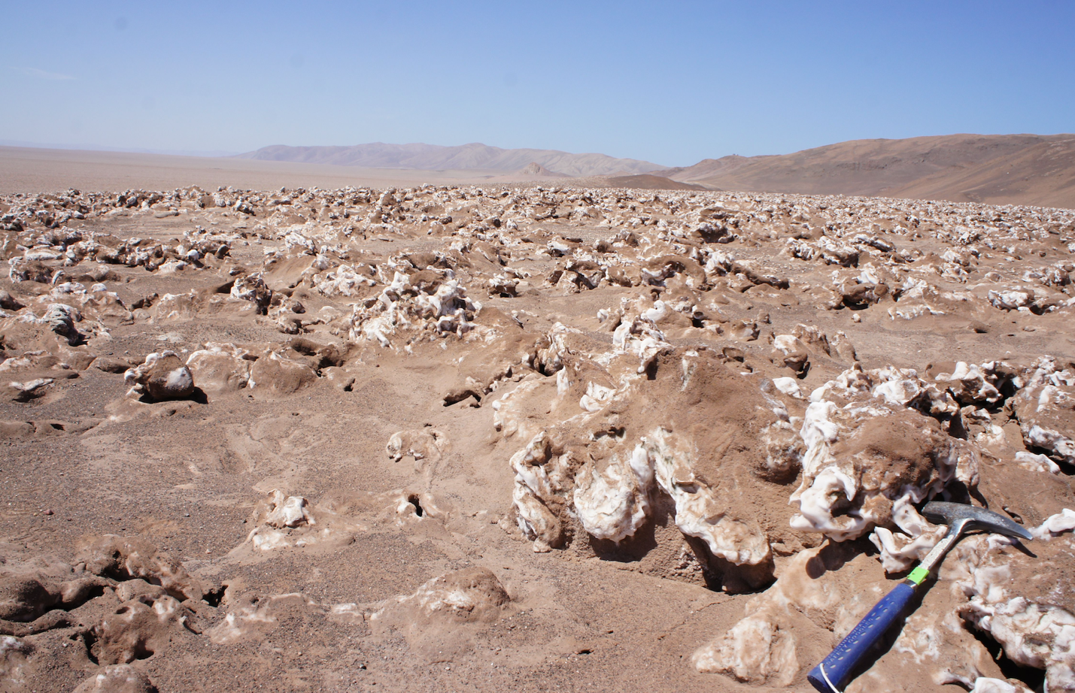

Fig. S1: A photograph of the sampling site, showing halite nodules scattered on the surface of Salar Grande. A 25 cm geological hammer shown for scale.



Fig. S2: (A) Temperature, (B) relative humidity, and (C) light (PAR) fluctuations at the SG1 sampling site over an average day. Data were collected at ground level with a HOBO probe. Trend lines represent non-parametric regression with the LocalPolynomialKernel(q=6) method in pyqt_fit. Weather data was collected every hour from 2017-02-06 to 2017-02-28 (temperature and humidity measurements) and 2018-02-22 to 2018-02-25 (light measurements). Red dotted lines show time of sampling (9 am and 9 pm).



Fig. S3: Log values of ratios of the average transcription (transcripts per million reads; TPM) over the average abundance (copies per million reads) for high-quality metagenome-assembled genomes (MAGs; >70% completion, <5% contamination) across the 12 replicate samples. Color map corresponds to the Log 10 of the TPM values. Genome labels include full MAG identifiers.



Fig. S4: (A) Relationship between scaled metagenome-assembled genome (MAG) abundance (copies per million; CPM) and their respective mean expression (transcripts per million reads; TPM). The scaled values were calculated as follows: TPMscaled=(TPM-TPMmin)/(TPMmax-TPMmin), CPMscaled=(CPM-CPMmin)/(CPMmax-CPMmin). (B) Distributions of Pearson correlation coefficients in MAGs of the non-scaled TPM and CPM values across the 12 replicates. Panels C and D show the same analysis of CPM and TPM correlations but at the contig level.



Fig. S5: Relative prevalence of major KEGG functional pathways in the metagenomic and metatranscriptomic samples. The pathway abundance (DNA) and expression (RNA) value were the combined total copies per million and transcripts per million, respectively, of the genes that constituted that pathway. All samples were standardized to equal total coverage of all pathways and then scaled to the maximum value for each row (encoded in color map).



Fig. S6: Variation in pathway abundance in metagenome replicates (cyan) and variation in pathway expression in metatranscriptome replicates (gold) shown for major phylogenetic groups of the halite community.

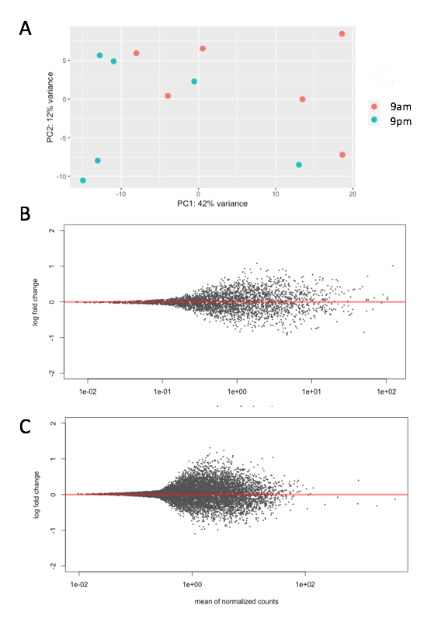

Fig S7. DESeq2 differential expression analysis of the halite community between the 9 am and 9 pm time points. (A) Clustering between the time points shown with a PCA of the expression profile of the entire community. (B) Lack of significantly differentially expressed genes (q-value<0.01) in the Halothece and (C) Dolichomastix draft genomes. Gene expression was expressed as transcripts per million (TPM) and further standardized to the total transcription of the contig (A) or genome (B,C) that they belong to in order to account for inter-replicate variation in abundance and activity.



Fig. S8: Mean transcriptional activity ratio (encoded in color map) of major highly-expressed KEGG pathways in the major taxa found in the halite communities. The relative activity is the ratio of total pathway expression (transcripts per million reads) to the pathway’s abundance (copies per million reads) in each taxon.



Fig S9: (A) Unrooted phylogenetic tree of a random subset of 500 Chlorophyta (green algae) species from the SILVA database, including all available sequences from the Mamiellophyceae class (highlighted in blue), constructed from a multiple alignment of 18S rRNA sequences. (B) Zoomed-in view of the Mamiellophyceae class phylogeny, showing the clustering of 18S rRNA gene sequences from the halite algae with members of the Dolichomastix genus (highlighted in blue; the closest sequence from Lake Tyrrel isolate under GenBank accession number KC486366.1).

Fig. S10: (A) Distribution of isoelectric points (pI) of predicted proteins in various algal genomes, including the novel Dolichomastix. (B) Predicted pIs of homologous proteins identified in both Dolichomastix and M. pusila genomes, showing biases in pI preferences between the two genomes. (C) GC content and average expression of Dolichomastix genes, with genes encoding homologs of proteins important for high-salt tolerance in D. salina highlighted in black. (D) Distribution of isoelectric points (pI) of predicted genes in Dolichomastix chromosomes, mitochondria, and chloroplast.



Fig. S11: Gene similarity network of RefSeq viruses (grey) and with viral contigs identified in this study (blue). Genus-level taxonomy was determined using VContact2 and inter-genome similarity was estimated with protein alignments with DIAMOND. Any genomes with no sufficient similarity to other genomes were not displayed.

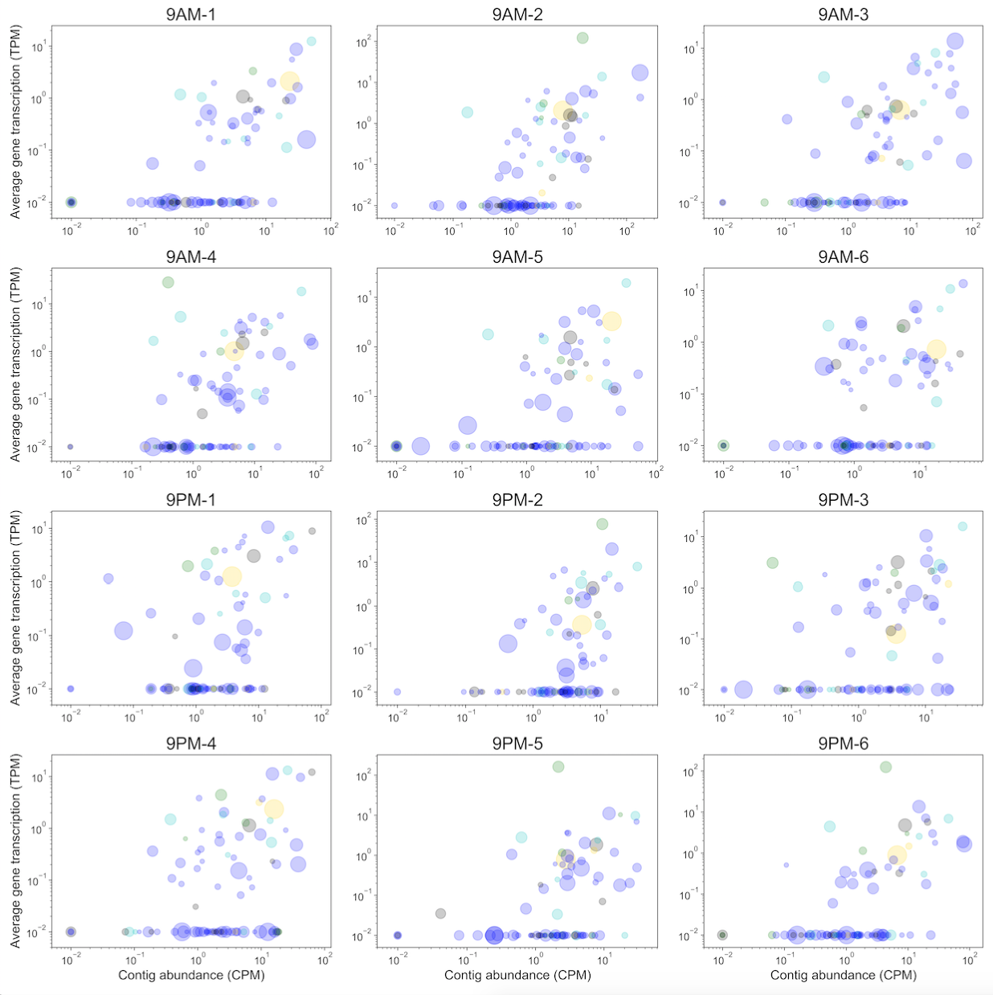

Fig S12: Viral contig total transcriptional activity (transcripts per million reads) and abundance (copies per million reads) across the 12 replicates. Size of circles represents the relative length of viral contigs and color denotes the taxonomy of predicted host (blue: Euryarchaeota, cyan: Proteobacteria, green: Cyanobacteria, gold: Bacteroidetes, gray: unknown).



Fig. S13: Distribution of Pearson correlation between total transcriptional activity (transcripts per million reads; TPM) and total abundance (copies per million reads; CPM) of viral contigs across the 12 replicates.



Fig. S14: RT-PCR validation of the lack of DNA contamination in the extracted RNA. Each RNA sample was processed using the SuperScript III cDNA synthesis kit with (RT+, positive control) or without (RT-, negative control) the reverse transcriptase enzyme. The 16S rRNA gene was amplified from the resulting cDNA. Pairs of library replicates (1 and 2, 3 and 4, 5 and 6, etc.) were pooled in-silico to produce the final RNAseq libraries. Arrows indicate the expected locations of amplicon bands (512 bp).